Company: Unlimited

Date: 2/2/20

Members: Kehan Meng, Linsong Li, Shixian Jing, Nicholas Boanca

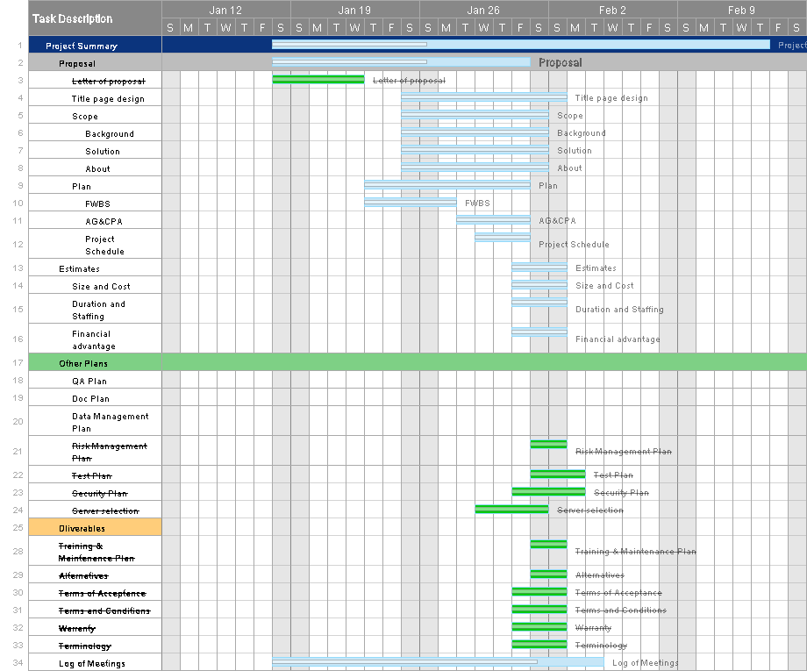

Work assignment:

Kehan Meng: Project schedule, risk management plan, training and maintenance plan, title page deisgn alternatives and log of meetings.

Linsong Li: FWBS, company logo design and estimation.

Shixian Jing: Test plan, security plan, server selection, modify scope.

Nicholas Boanca: AG, CPA, terms of acceptance, terms and conditions, warranty and terminology.